CITY OF SAVANNAH

VIOLENCE REDUCTION GRANTS

PROGRAM GUIDELINES

- Purpose

Savannah’s youth are among the community’s most precious assets, and their safety and wellbeing is a priority for the City of Savannah. To achieve this goal, the City of Savannah Office of Neighborhood Safety and Engagement (ONSE) is making funding available to support community programs, services and initiatives focused on reducing gun violence among Savannah’s youth and young adults, ages 12 to 25, who have been or are identified as being at high risk of involvement in gun and other violence. High-risk youth are defined as those who have a history of involvement in violent crimes as a perpetrator or victim, or who has been regularly exposed to violence because of their associations. The CDC gives eight (8) factors that identify youth as being at high-risk as being a perpetrator of violence. These factors include being a victim of violence, substance abuse history, poor behavioral control, having a deficit in social cognitive abilities, high emotional distress, history of treatment for emotional disorders, anti-social behaviors, exposure to violence in their families, and hyperactivity.

Non-profit organizations are invited to submit proposals seeking funding support for eligible activities. Proposals may receive an award up to a maximum of $50,000 for allowable expenses. All costs must be reasonable with regard to the type and the dollar amount of the expense, with no more than 15% of grant funds eligible for administrative costs. All administrative costs must be directly related to the program or service being funded.

Applications will be considered based on the merit of the program and the ability of the program to achieve measurable results, meet a priority need, and aid in reducing youth gun and other violence. Funding levels will be considered based on the availability of funds allocated to the Violence Reduction Grant Program, the City’s funding priorities, the number of proposals recommended for funding, and the specific services being purchased. The City reserves the right to purchase all or a portion of the proposed services, and grant awards may be less than the amount requested.

The application period begins on Saturday, June 7th, 2025 and closes at 5:00 p.m. on Friday, July 18th, 2025. Applications received after 5:00 p.m. on this date will not be considered for funding.
- Eligible Organizations
Entities submitting proposals must meet the following requirements:
- Be a legally formed not-for-profit (non-profit) entity registered in the state of Georgia and able to provide proof of the non-profit entity’s legal formation. Non-profit organizations are formed in Georgia by filing with the Corporations Division of the Office of Secretary of State. For more information or to retrieve a copy of the organization’s Georgia certificate visit: https://ecorp.sos.ga.gov/BusinessSearch
- Be located within the corporate city limits of Savannah.
- Provide services directly benefitting residents of Savannah, Georgia.
- Agencies requesting $25,000 or more must submit a profit and loss statement or financial statements prepared by an Independent Auditor or Certified Public Accountant in accordance with generally accepted auditing principles. For agencies requesting less than $25,000 a profit and loss statement0 prepared by the agency and a full copy of the agency’s 990 submission to the Internal Revenue Service (IRS) for the last completed tax season will be accepted. Any areas of concern identified in the agency’s profit and loss statement, 990, or summary of reviewed financial statement will be addressed during the proposal review period and in consultation with the City’s Office of Management and Budget.

- Eligible Programs/Projects
All projects must meet the following requirements:
- Be realistic and well-planned.
- Be implemented in Savannah, Georgia, and benefit Savannah residents.
- Have measurable performance goals that can be reported to the City and community.
- Address the needs of youth and/or young adults at high risk of engagement in or becoming victims of gun and other violence.
- Result in outcomes that reduce gun and other violence and negative behaviors among participants or within a clearly defined community or geographic area.
- Address one or more of the following service continuum needs:
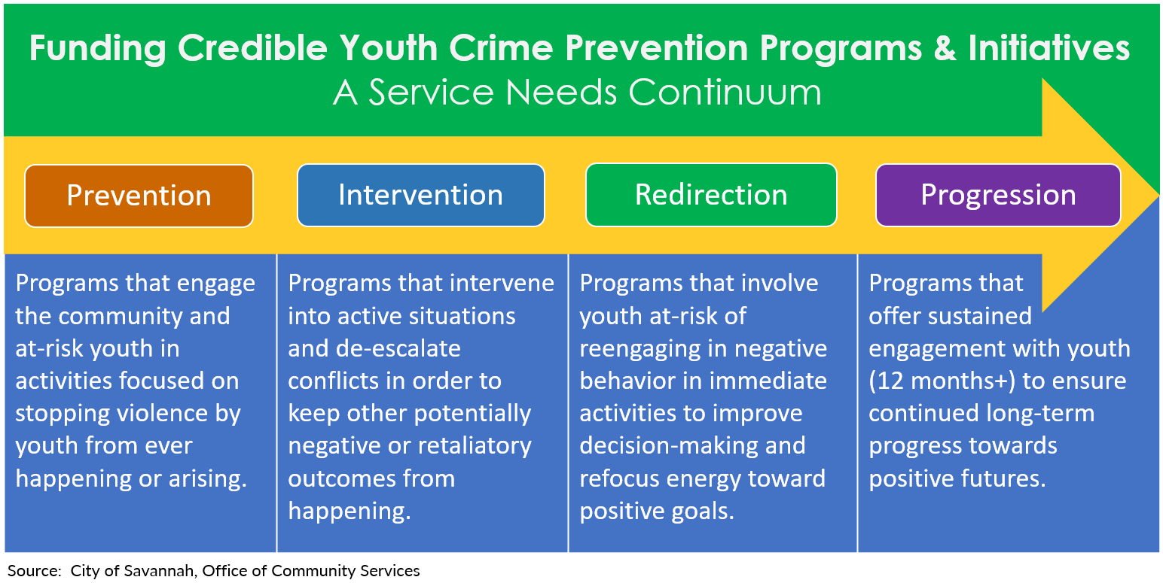

- Eligible Program Costs
Funds may be used to support direct project costs, such as program/project supplies and materials, equipment rentals, production fees, instructor/trainer fees, etc. Funds may not be used for: salaries; inherently religious activities; lobbying, political activities or patronage; existing debts or financial liabilities; cash benefits or payouts; ongoing operating or administrative expenses not directly related to the project; fundraising; private events or other activities that are closed to the general public, restricted to an organization’s membership or restricted on the basis of race, color, national origin, disability, age, gender or sexual orientation; or any other activities outside the scope of the project.

- Application Procedures
- Applications must be completed on the Violence Reduction Grant Application Form and submitted to the Office of Neighborhood Safety and Engagement, along with ALL required documentation, including the itemized program budget, proof of non-profit legal status in the State of Georgia, the Employer Identification Number, and proof of 501c.3 tax exemption by the Internal Revenue Service. Applicants must provide proof of estimated program expenses if requested by the City. Incomplete or late applications will not be considered.
- Approved applicants must enter into a Grant Agreement with the City and comply with all performance and reporting requirements, including submittal of periodic performance reports and all required supporting documentation, including but not limited to:
  - Program materials that document program completion, such as promotional materials, social media posts, sign-in sheets with the title, dates and locations of all funded activities/events, participant lists, event/activity photos, etc.
  - Participant information including names, addresses, contact information, services received, program attendance, benefits gained, and long-term outcomes regarding reengagement in violence.
  - A summary of measurable performance goals achieved, and benefits gained among direct participants, the target community or defined geographic area as a result of participation in the program or implementation of the project.

IMPORTANT NOTICE: Failure to provide requested information or misuse of funds can result in repayment of City funds and placement on a Do Not Fund list.

- Program Monitoring and Record Keeping
The City of Savannah may visit program sites, request to review program records, confirm program participants, contact program partner organizations, and/or assess the progress of funded activities at any time. Therefore, it is extremely important that funded organizations establish a record keeping process BEFORE initiating the project, to ensure records can be reviewed at any time. Organizations are encouraged to contact City staff for guidance and suggestions on how to set up procedures to collect and retain the types of records needed to verify successful implementation of activities and allowable use of public funds.

- Submission of Proposals
Proposals must be submitted electronically to the Office of Neighborhood Safety and Engagement by 5:00 p.m., Friday, July 18th, 2025 at onse@savannahga.gov. Late proposals will not be accepted. For more information, contact ONSE at (912) 651-2443.

Dahlberg, L. L., & Simon, T. R. (2006). Predicting and preventing youth violence: Developmental pathways and risk. In J. R. Lutzker (Ed.), Preventing violence: Research and evidence-based intervention strategies (pp. 97-124). Washington, DC: American Psychological Association.) The National Network for Safe Communities, through its evidence-based strategy, identifies involvement in violent crimes as a perpetrator or being closely associated in a group with individuals who are perpetrators of gun violence as being a risk factor (National Network for Safe Communities, Group Violence Intervention: An Implementation Guide (Washington, DC: Office of Community Oriented Policing Services, 2013), http://ric-zai-inc.com/ Publications/cops-p280-pub.pdf.

