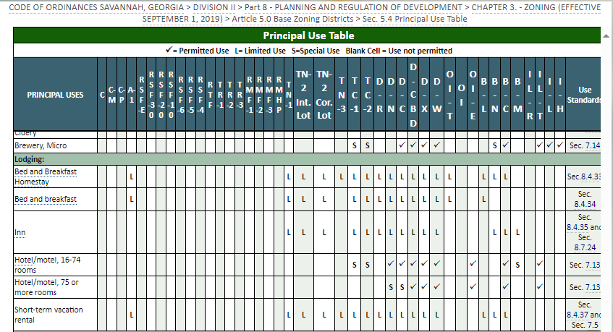

Sec. 5.4 Principal Use Table: Document Viewer | City of Savannah Code of Ordinances (encodeplus.com)

